St. Patrick’s Primary School
30 Burrenreagh Road, Castlewellan, BT31 9HH.

_________________________________________________________________________
Burrenreagh Newsletter January 2023

Christmas Raffle
Congratulations to all the winners of our Christmas Raffle which raised the magnificent sum of £899.90. Our top quality printer, supplied by Burke Office Solutions of Belfast was won by Caoimhe Duggan. Aisling McCallion won the overnight stay with breakfast for two at the Belfast Hilton. Our child’s bike, supplied by Ross Cycles was won by Angela Brannigan.

Welcome
We would like to welcome Finn Crawley who has started our school recently. We hope that Finn will have many happy years ahead at Burrenreagh.
School Closure
School will close for Mid-Term Break at 2.00pm on Friday 10th February and will be closed from Monday 13th February until Friday 17th February inclusive. School reopens for all pupils on Monday 20th February.

Confirmation
Primary 7 pupils will receive the Sacrament of Confirmation on Thursday 26th January at 5.00pm in Our Lady of the Assumption Church in Newcastle. Primary 7 pupils do not need to attend school that day. School will operate as usual for all other pupils.

Enrolment
If you know anyone who like to enrol their child in Burrenreagh, please pass on the following information.
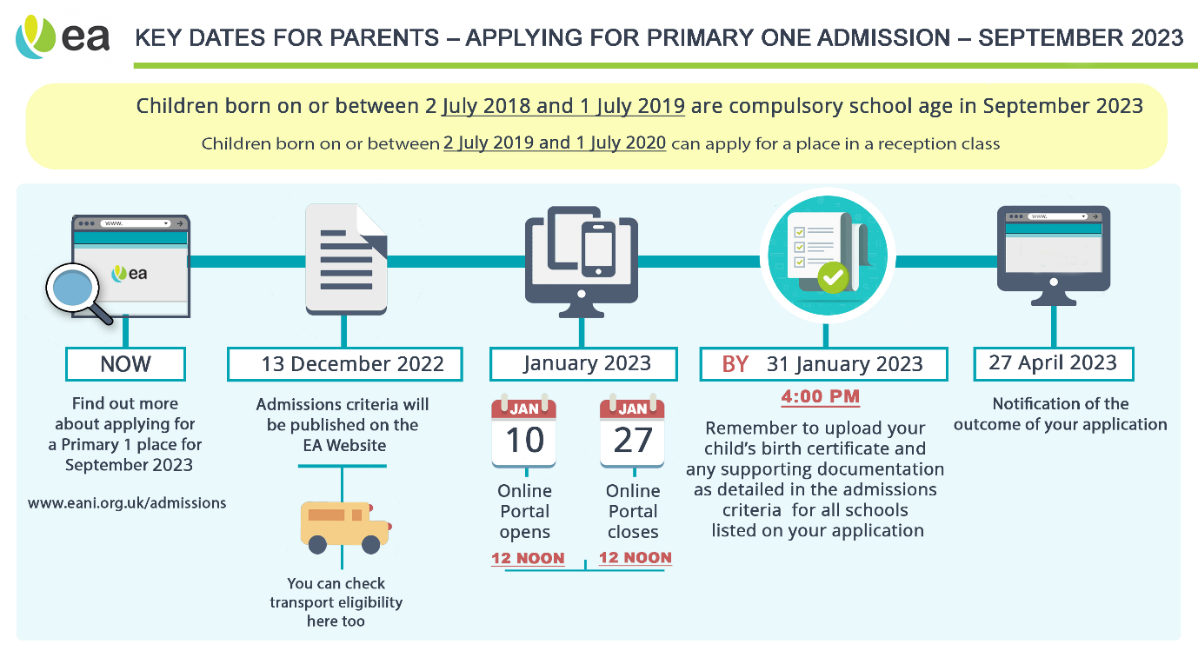
GAA Coaching Programme
This Photo by Unknown Author is licensed under CC BY

Primary 4 – 7 pupils will once again receive GAA coaching each week from Down GAA. The coaching this year will once again take place on Tuesday afternoons. Payment for Term 2 is £10. Thank you to those parents who have already paid. It is much appreciated. If you have not already done so, please send the payment into the office in an envelope with your child’s name clearly marked. Thank you.

Breakfast Club and After School Club.
Our Breakfast Club operates each morning from 8.00am. Our After School Club has resumed and runs each afternoon until 5.00pm. Anyone wishing to book the After School Club or Breakfast Club should contact the school office by email or phone each Friday before 12.00 noon for the week ahead, so that necessary staffing arrangements can be made. If a booking has not been made in advance, we may have to turn pupils away from these clubs as we may not have the staffing arrangements in place.
All payments for the week should be sent to the office each Monday.

Swimming Lessons
This Photo by Unknown Author is licensed under CC BY-ND
Swimming will take place each Monday at a cost of £6.00 per child. This amount covers the cost of lessons and bus hire. If your child cannot attend for any reason they must be picked up at 12.30pm.
Punctuality
This Photo by Unknown Author is licensed under CC BY-SA
It is vitally important for your child's education that they should arrive at school before our starting time of 8.45am. Failure to do so involves an electronic record being created on a central system which records your child's late arrival. This can have implications where it is on ongoing issue. We would appeal to all parents to ensure that their child(ren) arrive at school in good time each morning.

Cash for Clobber
Our cash for clobber collection for fundraising continues. If you have been clearing out old clothes, please save them for us. We welcome all donations of bags of any used clothing, shoes and fabrics. Nothing goes to waste. Each full bag raises approximately £3.00 for school funds. We have already had parents donating bags of Cash for Clobber this year. Thank you to everyone who has supported us in this initiative.

