St.Patrick’s P.S. Burrenreagh
Cumann Na mBunscoil
The girls and boys 7 aside gaelic football preliminary blitz will take place on Wednesday 17th May in Liatroim starting at 10 am. Two teams from this venue will qualify for the All-County semi finals.
We will be sending out consent forms to the pupils selected from P.5, P6 and P7.
30 Burrenreagh Road, Castlewellan BT31 9HH
Holidays/ School Closures
- Monday 29th May Bank Holiday
- Tuesday 30th May Staff Day

School Closes on Friday 30th June at 11.00 am for the Summer Holidays

First Holy Communion
Congratulation to our P.4 pupils who celebrated their First Holy Communion on Friday. Hope they all had a great day.
Thanks to Fr. Crudden for celebrating the sacrament for the pupils. A special thanks to Miss Clarke for all her hard work preparing the pupils for this very special sacrament.

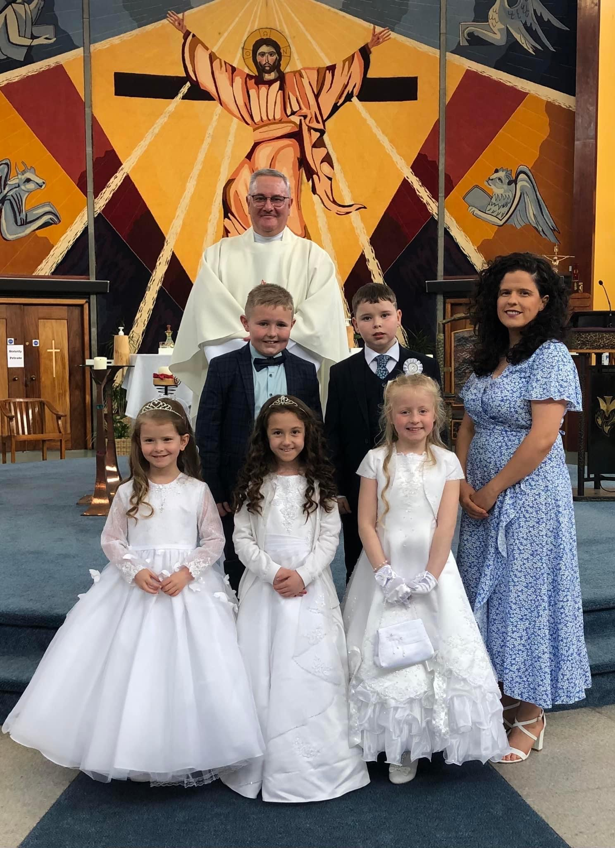

School Trips
On Tuesday 20th June our P.6 and P7. Pupils will go to Life Adventure in Castlewellan Forest Park. They will take part in a full days activities including Paddle Boarding, Archery and Climbing wall. The pupils should be left off at Life Adventure Centre at 9.30am and picked up at 3.30pm. The total cost for the whole day is £40.
Our P1-P5 pupils will go to Mountpanther Farm Park on Wednesday 28th June. We will leave school at 9.00am and return at 2.50pm. The cost of this trip is £12.50.

Patrick’s P.S. Burrenreagh
Burrenreagh Road, Castlewellan BT31 9HH
Sports Day
Sports day will be on Friday 2nd June. (Weather permitting) The pupils from Rec. to P.7 will be arranged in teams and allocated a team colour. If pupils could wear a shirt of their team colour on the day that would be a great help. While in their teams P.7 pupils will supervise the pupils to ensure good behaviour and getting ready for the races. Points will be awarded to the best teams. The best team will get a treat at Prize giving. Parents will be asked to sit at the Car Park side of the field and pupils will be at the other side of the running track. This is to discourage pupils running back and forward to their parents and to help with the smooth running of the events. The sports will start at 9.30. We will have a break at 10.45 when pupils can go to their parents. It is hoped to have a Coffee trailer in attendance. Races will restart at 11.00am. The sport should be over at 12.30 when pupils may go home.
Breakfast Club and After School Club.
Our Breakfast Club operates each morning from 8.00am. Our After School Club runs each afternoon until 5.00pm. Anyone wishing to book the After School Club or Breakfast Club should contact the school office by email or phone each Friday before 12.00 noon for the week ahead, so that necessary staffing arrangements can be made. If a booking has not been made in advance, we may have to turn pupils away from these clubs as we may not have the staffing arrangements in place. All payments for the week should be sent to the office each Monday

Third Term Fundraiser
The 3rd term fundraiser will be a Smarties challenge based on Summer. The first part of the Challenge is for our pupils to eat the smarties! Then will need help from family and friends to fill the empty tube with coins. After the tube is filled, the pupils must use summer as a theme to decorate their tube. We hope to have prizes for the best decorated tubes. Good Luck Everyone!

Cash for Clobber
Our cash for clobber collection for fundraising continues. If you have been clearing out old clothes, please save them for us. We welcome all donations of bags of any used clothing, shoes and fabrics. Nothing goes to waste. Each full bag raises approximately £3.00 for school funds. We have already had parents donating bags of Cash for Clobber this year. Thank you to everyone who has supported us in this initiative.

